ESC Design
  - Bare Metal Factory – Stepane Binon

Hardware design

Sizing
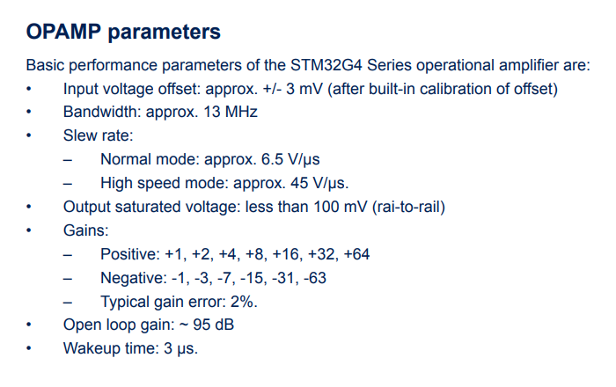

Schematic

Layout
The importance of section in the layout is as follow:
- 20V Hot Loop
- 10V Control and sensing
- MCU and other
The 20V Hot loop area must be minimized as much as possible to reduce the EMI. This loop is composed, as seen in Section X, like so: the battery input VBAT -> of the HS -> LS mosfets (of another phase) -> power GND.
Different designs can exist for the 20V Hot Loop (20VHL) and ANX X rank them. We decided to use design number X, presented in Figure X.

ANNEXES

Designs for the 20V Hot Loop (20VHL)
This annex ranks different designs for the 20VHL.
- BAD DESIGNS
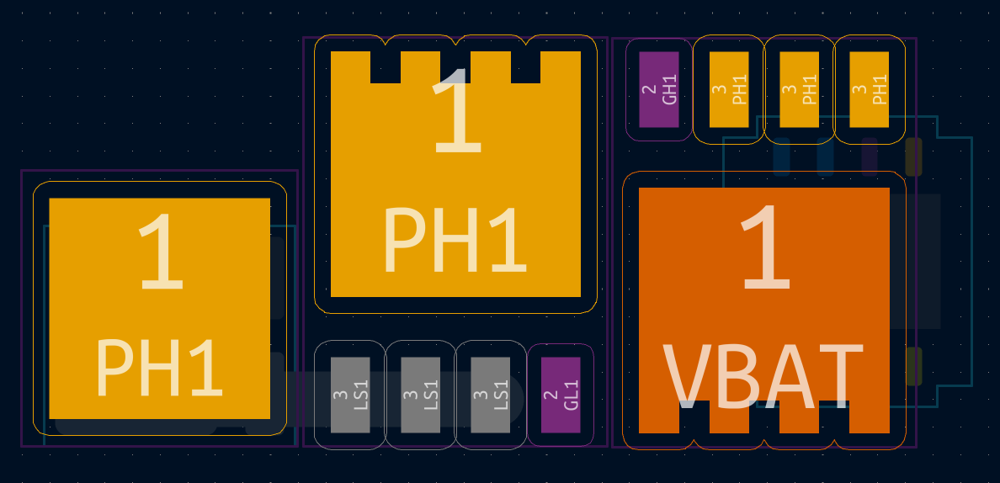
Figure 1: No direct link between PH1 in HS and LS mosfets.
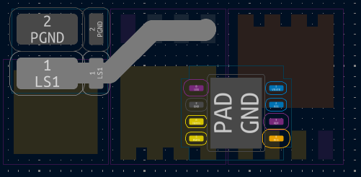
Figure 2: Double loop other PGND as LS1->PGND->GNDBAT. Sacrifices Kelvin resistor.
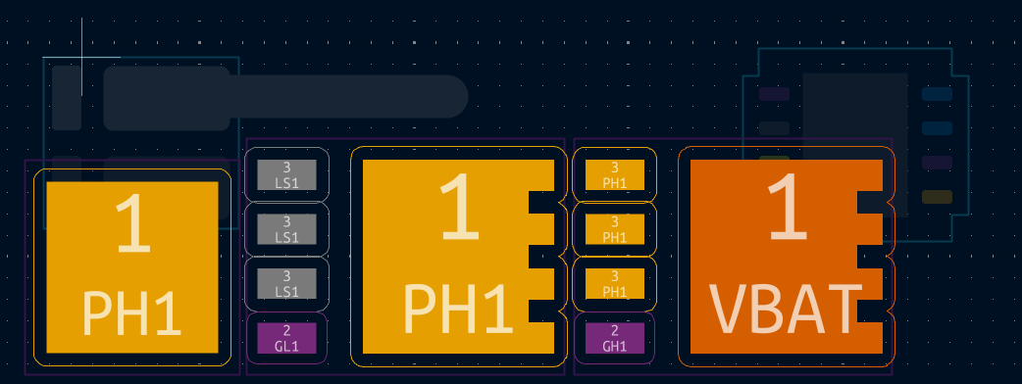
Figure 3: Long hot loop and the pad cannot be accessed easily.
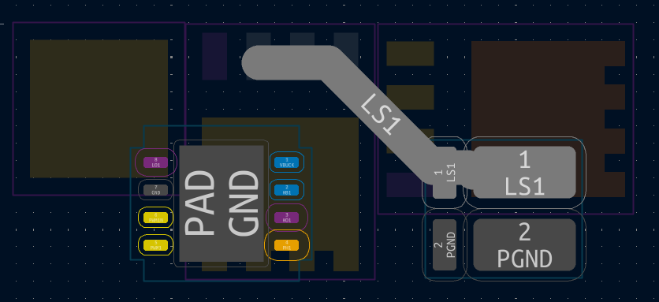
Figure 4: Link between PH1 in HS and LS mosfets awkward.
- MEDIUM DESISGNS
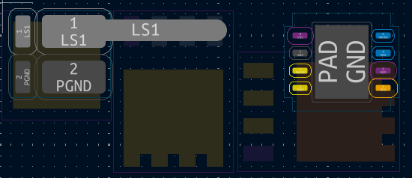
Figure 5: Shorter hot loop but the gate driver is further appart.
- GOOD DESIGNS
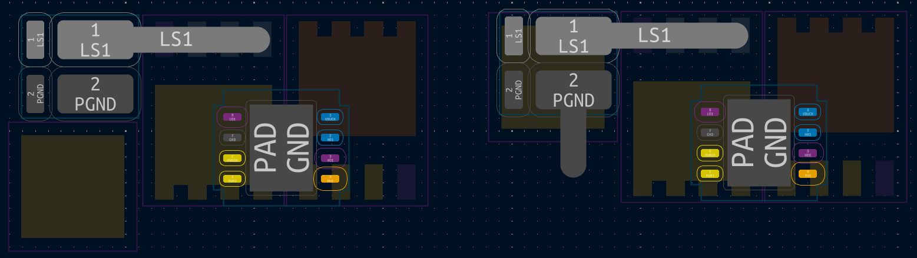
Figure 6: Good orientation for the gate driver, small footprint if PGND deported (right).
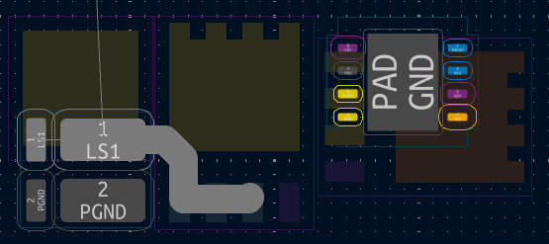
Figure 7: Driver placement awkward.
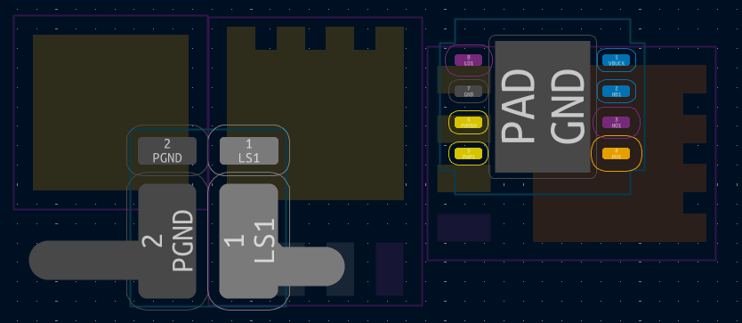
Figure 8: PGND is opposite from the BATGND with respect to LS1 -> current flow in the oposite direction -> HL longer.
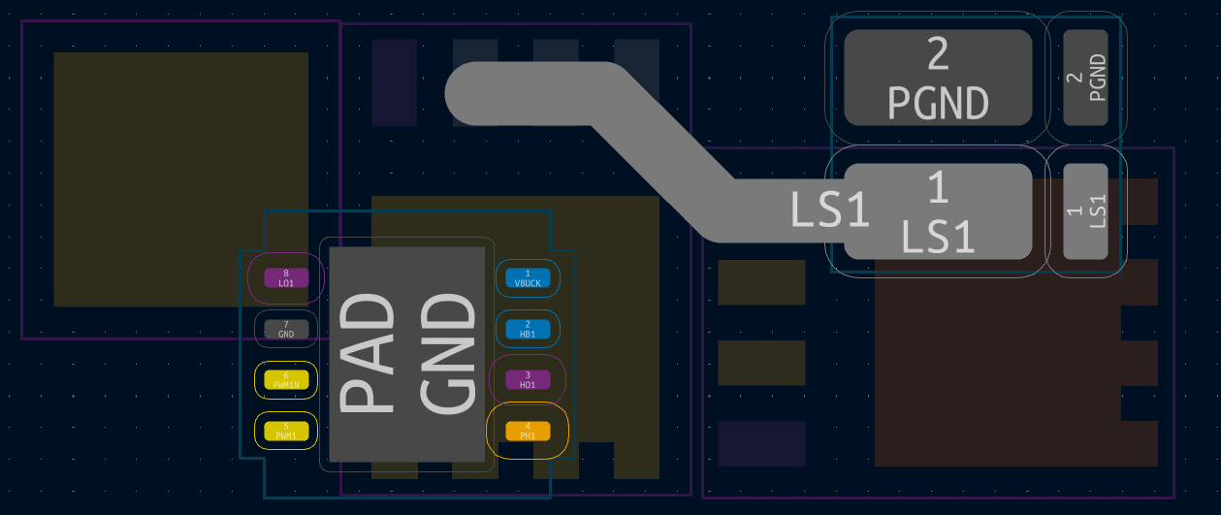
Figure 9: Almost the shortest path.

